## Workday integration:

The SOAP apis are more comprehensive when compared to the REST apis exposed i.e. the equivalent of some of the apis exposed by SOAP are not available in REST.

Eg:

**Use case - Candidate creation:**

*Register user in workday as a prospect:*

Required informtion: firstName, lastName, emailAddress, phoneNumber

Both SOAP and REST exposes apis for this purpose

*Register user in workday as a Candidate:*

**A prospect becomes a candidate when a jobID is associated with the user's record in workday.**

API to achieve this is exposed by SOAP but the equivalent is not available in REST.

In order to be able to communicate with the workday system, a seamless consumption of the apis (REST or SOAP) needs to be facilitated.

POCs have been done on both fronts with successful results.

### REST integration:

Steps to access the REST APIs:

1. Obtain the access token from the registered API client

Method: JWT Bearer grant

Request method: POST

Endpoint: <https://impl-services1.wd12.myworkday.com/ccx/oauth2/ust_dpt1/token>

Tenant: ust_dpt1

Body type: x-www-form-urlencoded

grant_type = urn:ietf:params:oauth:grant-type:jwt-bearer

assertion = <JWT token>

Steps to create the JWT token supplied to the key ‘assertion’ in x-www-form-urlencoded body:



Using the steps mentions in this pdf **a JWT token signed with a private key** that contains the API client ID and the ISU username can be generated and supplied to the aforementioned endpoint to procure the access_token.

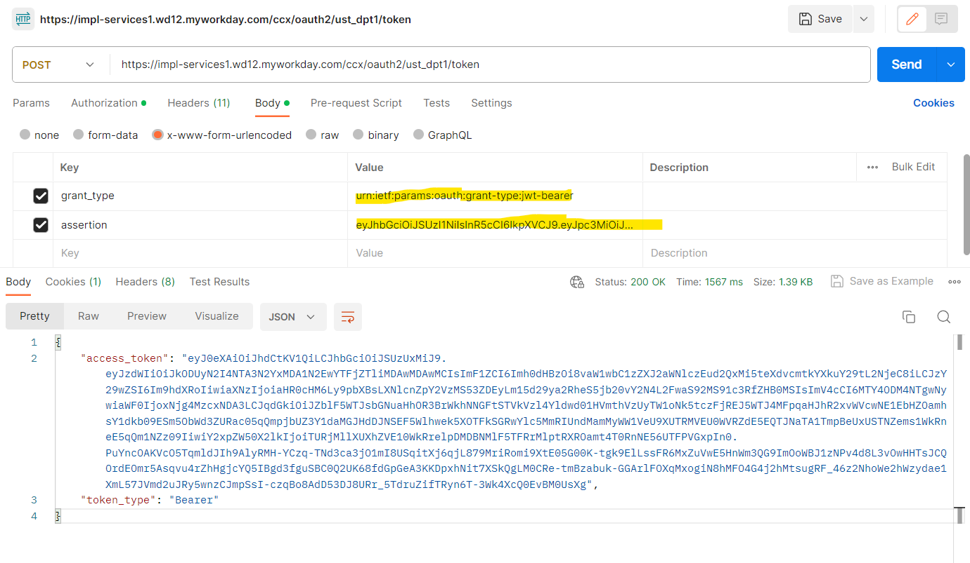

1. Access the rest endpoint

Request type: Depends on the api

Workday api endpoint: <https://impl-services1.wd12.myworkday.com/ccx/api/recruiting/v2/ust_dpt1/prospects>/{id}

This endpoint is used to get the prospect based on the prospect id.

Endpoint structure breakup: https://<baseurl>/api/<scope>/<version>/<tenant>/prospects

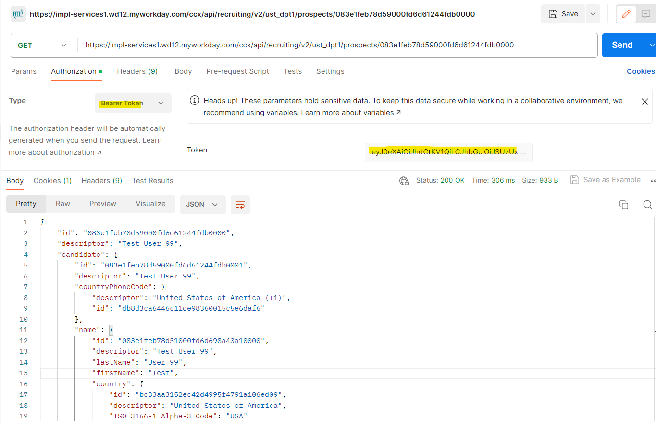

### **NOTE: For performing this integration from code an SSLHandshake is required at the time of accessing the workday apis. To do this a truststore needs to be created using the pem file. Steps to achieve this at runtime is included here** [FeignConfiguration.java](https://github.com/Round-Feather/bayada/blob/develop/src/main/java/com/bayada/joy/config/FeignConfiguration.java)